**OBSTACLE AVOIDING ROBOT USING ULTRASONIC SENSOR**

**INTRODUCTION**

**PROJECT BACKGROUND:**

Mobile robot are often employed to deal with activities that are dangerous and activities that involve in an uncomfortable environment. Mobile robot are applicable in various industries such as aerospace, chemical, construction, manufacturing and others. High temperature environment in manufacturing processes are one of the example that require mobile robot. Obstacle avoidance strategy is an algorithm of the mobile robot’s action when detecting an obstacle. The purpose of the obstacle avoidance strategy is to prevent the robot from any collision with any object or obstacle which may cause damage to the obstacles and the mobile robot itself. In aerospace industry, numerous mobile robot are used in an unknown place which does not have information of the obstacle around the place while in manufacturing or chemical industries, raw materials, machines, parts and products are the examples of the obstacles for mobile robot. Thus, it is also important to prevent any damage on the component. In obstacle avoidance, obstacle detection are important element to decide the motion and direction of the mobile robot. For example, a mobile robot will accelerating until optimum speed if obstacle are far from the mobile robot while mobile robot will decelerate if obstacle are close to it and make a turn. There was difference of sensor or process that used for obstacle detection such as sonar sensor, image processing and others.

Sonar sensor is one of the common sensor that is used to detect the obstacle. The sensor detects the range between the sensor and obstacle by transmitting ultrasound wave with constant wavelength which will be reflected by the obstacle. The transmitter are used to send the transmitted wave and the receiver are used to receive the reflected wave. Sonar sensor does not depend on the colour of the object. There are a few disadvantages of sonar sensor. Sonar sensor have a range of sensing range. Other than that, the change of environment will affect the accuracy of the sonar sensor such as humidity and temperature.

**PROBLEM STATEMENT:**

Numerous field of industry have use mobile robot or each application and other industries are start to consider mobile robot in their applications since the improvement of technology lately. Obstacle avoidance system provides safety for both mobile robot and obstacles around. This would prevent any costing for repair and without increase the cost of maintenance or repair of the mobile robot. Mobile robot without obstacle avoidance will be unsafe for both obstacles and mobile robot. In critical situation, it may cause accident that causes major losses.

**OBJECTIVE:**

To develop an algorithm for obstacle avoidance mobile robot using ultra sonic sensor and Arduino Uno.

**OBSTACLE AVOIDING ROBOT**

An Obstacle Avoiding Robot is a type of autonomous mobile robot that avoids collision with unexpected obstacles.

**HARDWARE REQUIRED:**

* Arduino Uno
* Ultrasonic Sensor – HC – SR04
* Motor Driver IC – L293D
* Servo Motor (Tower Pro SG90)
* Geared Motors x 2
* Robot Chassis
* Power Supply
* Battery Connector
* Battery Holder

### COMPONENT DESCRIPTION:

#### **Arduino Uno:**

Arduino Uno is an ATmega 328p Microcontroller based prototyping board. It is an open source electronic prototyping platform that can be used with various sensors and actuators.

Arduino Uno has 14 digital I/O pins out of which 6 pins are used in this project.

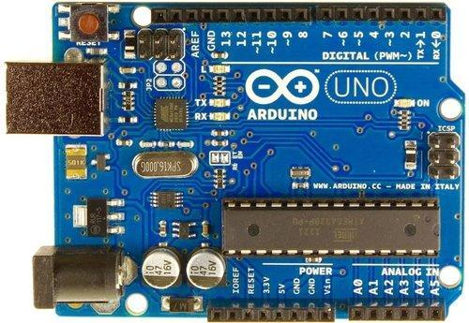

#### **HC – SR04**

It is an Ultrasonic Range Finder Sensor. It is a non-contact based distance measurement system and can measure distance of 2cm to 4m.

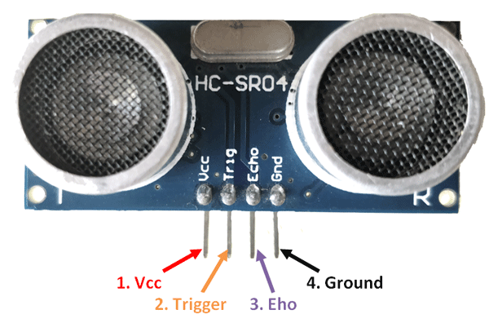

#### **L293D**

It is a motor driver which can provide bi-directional drive current for two motors.

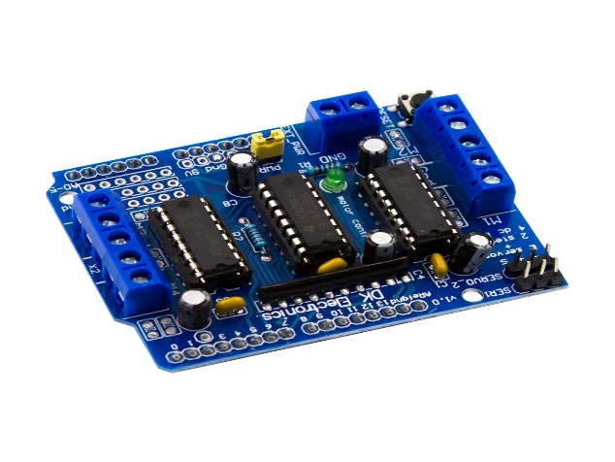

#### **Servo Motor**

The Tower Pro SG90 is a simple Servo Motor which can rotate 90 degrees in each direction (approximately 180 degrees in total).

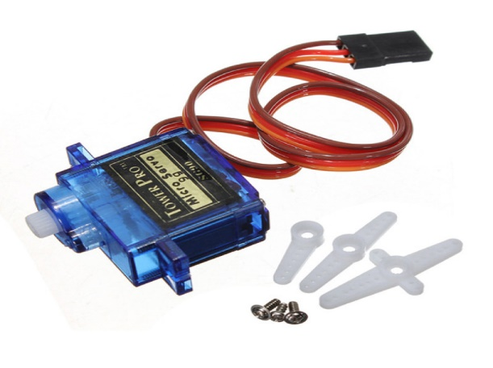

**BLOCK DIAGRAM**

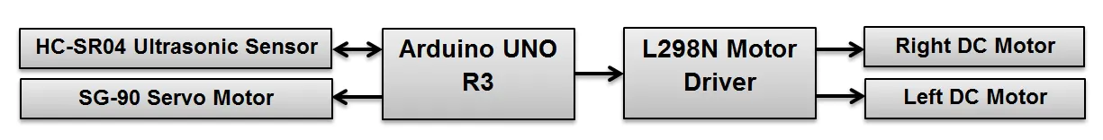

### CIRCUIT DIAGRAM

### Obstacle Avoiding Robot using Arduino Circuit 1

### DESIGN OF OBSTACLE AVOIDING ROBOT USING ARDUINO:

Arduino is the main processing unit of the robot. Out of the 14 available digital I/O pins, 7 pins are used in this project design.

The ultrasonic sensor has 4 pins: Vcc, Trig, Echo and Gnd. Vcc and Gnd are connected to the +5v and GND pins of the Arduino. Trig (Trigger) is connected to the 9th pin and Echo is connected to 8th pin of the Arduino UNO respectively.

A Servo Motor is used to rotate the Ultrasonic Sensor to scan for obstacles. It has three pins namely Control, VCC and GND. The Servo Control Pin is connected to pin 11 of Arduino while the VCC and GND are connected to +5V and GND.

L293D is a 16 pin IC. Pins 1 and 9 are the enable pins. These pins are connected to +5V.  Pins 2 and 7 are control inputs from microcontroller for first motor. They are connected to pins 6 and 7 of Arduino respectively.

Similarly, pins 10 and 15 are control inputs from microcontroller for second motor. They are connected to pins 5 and 4 of Arduino. Pins 4, 5, 12 and 13 of L293D are ground pins and are connected to Gnd.

First motor (consider this as the motor for left wheel) is connected across the pins 3 and 6 of L293D. The second motor, which acts as the right wheel motor, is connected to 11 and 14 pins of L293D.

The 16th pin of L293D is Vcc1. This is connected to +5V. The 8th pins is Vcc2. This is the motor supply voltage. This can be connected anywhere between 4.7V and 36V. In this project, pin 8 if L293D is connected to +5V supply.

### WORKING

Before going to working of the project, it is important to understand how the ultrasonic sensor works. The basic principle behind the working of ultrasonic sensor is as follows:

Using an external trigger signal, the Trig pin on ultrasonic sensor is made logic high for at least 10µs. A sonic burst from the transmitter module is sent. This consists of 8 pulses of 40KHz.

The signals return back after hitting a surface and the receiver detects this signal. The Echo pin is high from the time of sending the signal and receiving it. This time can be converted to distance using appropriate calculations.

The aim of this project is to implement an obstacle avoiding robot using ultrasonic sensor and Arduino. All the connections are made as per the circuit diagram. The working of the project is explained below.

When the robot is powered on, both the motors of the robot will run normally and the robot moves forward. During this time, the ultrasonic sensor continuously calculate the distance between the robot and the reflective surface.

This information is processed by the Arduino. If the distance between the robot and the obstacle is less than 15cm, the Robot stops and scans in left and right directions for new distance using Servo Motor and Ultrasonic Sensor. If the distance towards the left side is more than that of the right side, the robot will prepare for a left turn. But first, it backs up a little bit and then activates the Left Wheel Motor in reversed in direction.

Similarly, if the right distance is more than that of the left distance, the Robot prepares right rotation.  This process continues forever and the robot keeps on moving without hitting any obstacle.

**CODE**

Code

/* Obstacle Avoiding Robot Using Ultrasonic Sensor and Ard

int trigPin = 9; // trig pin of HC-SR04

int echoPin = 10; // Echo pin of HC-SR04

int revleft4 = 4; //REVerse motion of Left motor

int fwdleft5 = 5; //ForWarD motion of Left motor

int revright6 = 6; //REVerse motion of Right motor

int fwdright7 = 7; //ForWarD motion of Right motor

long duration, distance;

void setup() {

delay(random(500,2000)); // delay for random time

Serial.begin(9600);

pinMode(revleft4, OUTPUT); // set Motor pins as output

pinMode(fwdleft5, OUTPUT);

pinMode(revright6, OUTPUT);

pinMode(fwdright7, OUTPUT);

pinMode(trigPin, OUTPUT); // set trig pin as output

pinMode(echoPin, INPUT); //set echo pin as input to capture reflected waves

}

void loop() {

digitalWrite(trigPin, LOW);

delayMicroseconds(2);

digitalWrite(trigPin, HIGH); // send waves for 10 us

delayMicroseconds(10);

duration = pulseIn(echoPin, HIGH); // receive reflected waves

distance = duration / 58.2; // convert to distance

delay(10);

// If you dont get proper movements of your robot then alter the pin numbers

if (distance > 19)

{

digitalWrite(fwdright7, HIGH); // move forward

digitalWrite(revright6, LOW);

digitalWrite(fwdleft5, HIGH);

digitalWrite(revleft4, LOW);

}

if (distance < 18)

{

digitalWrite(fwdright7, LOW); //Stop

digitalWrite(revright6, LOW);

digitalWrite(fwdleft5, LOW);

digitalWrite(revleft4, LOW);

delay(500);

digitalWrite(fwdright7, LOW); //movebackword

digitalWrite(revright6, HIGH);

digitalWrite(fwdleft5, LOW);

digitalWrite(revleft4, HIGH);

delay(500);

digitalWrite(fwdright7, LOW); //Stop

digitalWrite(revright6, LOW);

digitalWrite(fwdleft5, LOW);

digitalWrite(revleft4, LOW);

delay(100);

digitalWrite(fwdright7, HIGH);

digitalWrite(revright6, LOW);

digitalWrite(revleft4, LOW);

digitalWrite(fwdleft5, LOW);

delay(500);

}

}

### APPLICATIONS

* Obstacle avoiding robots can be used in almost all mobile robot navigation systems.
* They can be used for household work like automatic vacuum cleaning.
* They can also be used in dangerous environments, where human penetration could be fatal.

-TEAM IMPULSE

B. Keerthana

S.V. Sahithi

P. Sreeja

V. Bhavani